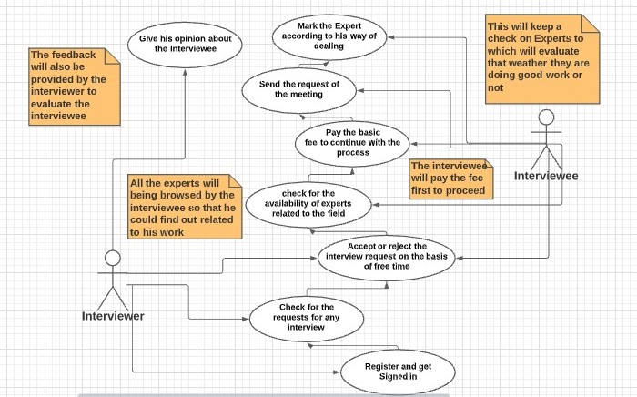

|  |
| --- |
| **USE CASE DESCRIPTION** |
| **Use Case Title: Talent Connector (The talent connector is a platform where the person who are facing some kind of problem in initiating the things up can interact with the experts directly which will enable them to sort out issues)** |
| **Level: Blue** |
| **Primary Actor: Interviewer, Interviewee** |
| **Stakeholders: Interviewer, Interviewee, Maintenance team** |
| **Precondition: The Interviewer first have to register himself and then login to the system to access the functionalities.** |
| **Minimal Guarantee: the fees of those applicants or interviewees who are not approved to join the sessions with the interviewers or we can say the experts are refunded** |
| **Success Guarantee: 1. The information regarding the expert or interviewer will be valid**  **2. The method used for the purpose of payments will be kept secure.** |
| **Main Success Scenario:**   1. **The expert of the field in which user have some problem can be searched by the user.** 2. **The user will ask the expert for a meeting by sending a request.** 3. **Is the expert will have the time for the meeting i.e., if he doesn’t have any other meeting, he will accept or reject the request on that basis.** 4. **The interviewee will pay the fee first to proceed.** 5. **This will keep a check on Experts to which will evaluate that weather they are doing good work or not** 6. **The feedback will also be provided by the interviewer to evaluate the interviewee** |
| **Extensions:**   1. **The user can ask for refund if he has not been approved and the money is deducted.** 2. **The user can use the forget password option in case he forgot the one.** 3. **If in case there is some issue regarding search or anything the user can contact the maintenance team.** |
| **3.Forgeting the credentials**  **User can change username or password using email linked with application.** |
|  |
|  |
|  |